**CS-359 Assignment-8**

Name: P. V. Sriram

Roll No.: 1801CS37

I have implemented a TCP proxy server using select() and fcntl() system calls. Incoming connection requests from the browser are redirected to the proxy server through a local server over TCP. The select() system call services multiple requests over different sockets and the fcntl() system call is used for non-blocking I/O. Since the institute proxy IP and port mentioned in the

**Proxy Configuration**

My IP Address: 172.17.32.226

Listen Port: 8181

Proxy IP: 165.225.77.46 {USA}

Proxy Port = 8800

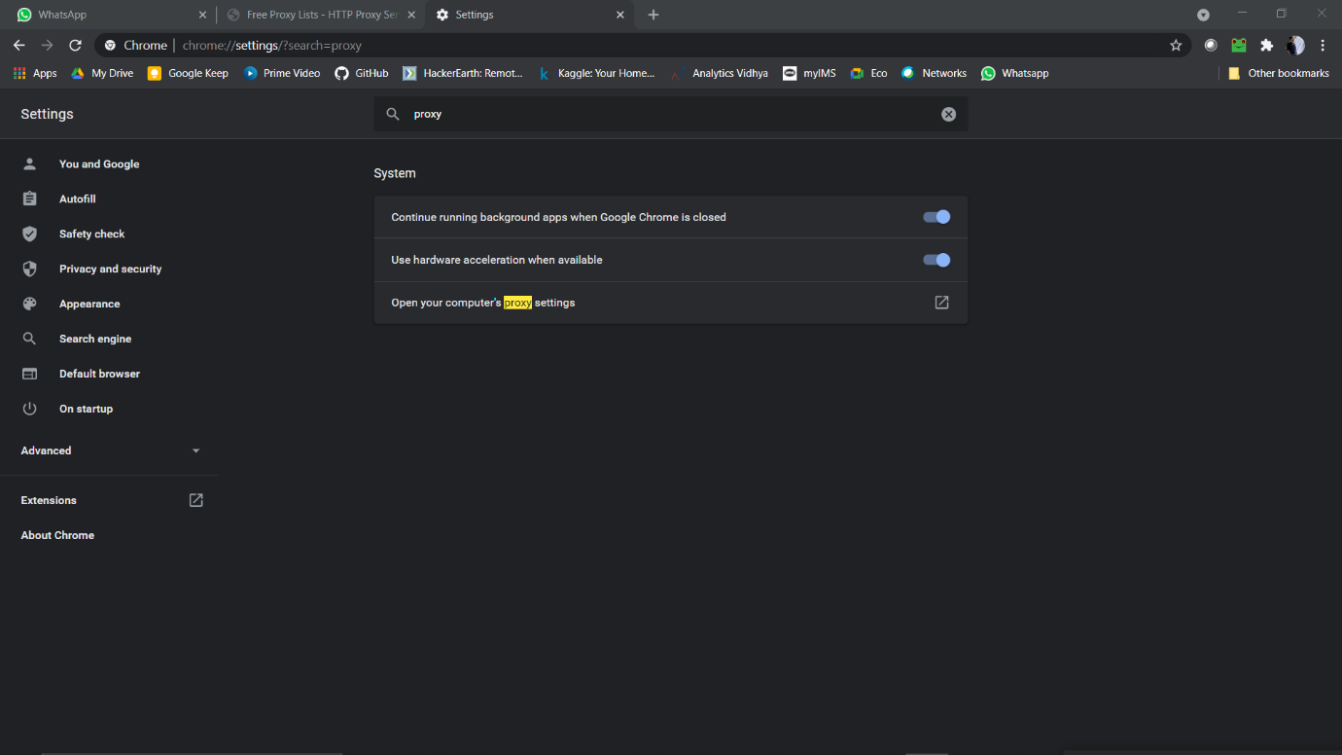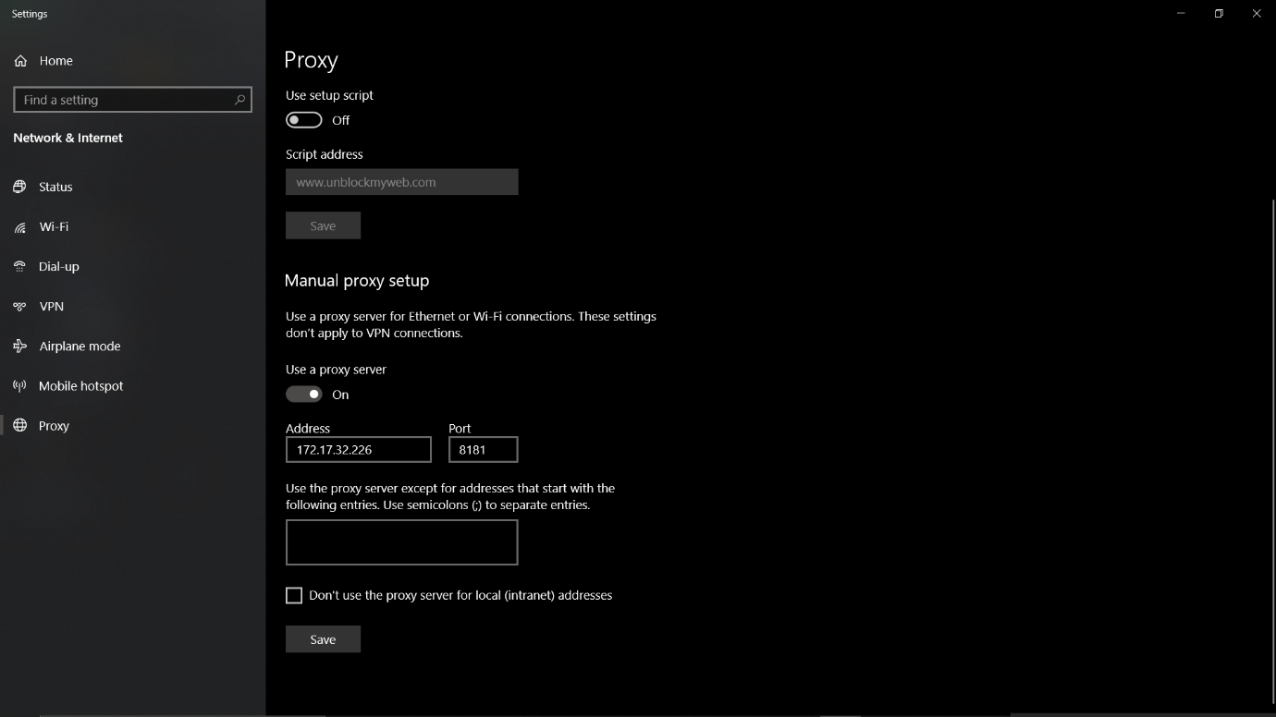

**Compilation and Execution**

To Compile: Gcc Ass8.c -0 Ass8

To Run: ./Ass8 8181 165.225.77.46 8800

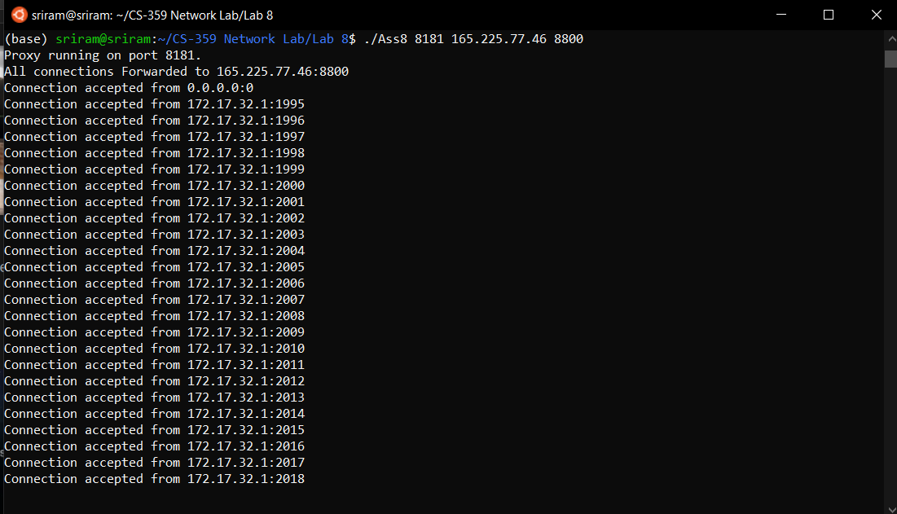

**Wireshark**

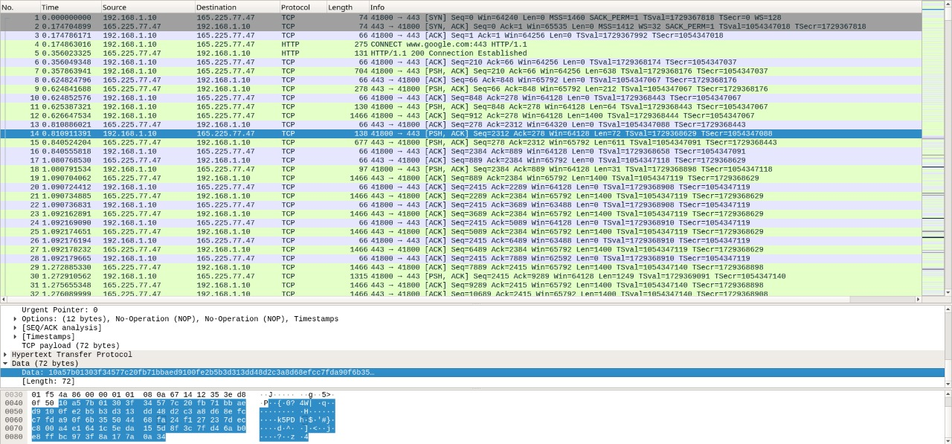

Packets Captured = 964